SPM PRACTICAL
Q5: Compute Estimate At Completion (EAC) and Variance At Completion (VAC) if both SPI and CPI influence the project work when given variables are:
- Budget At Completion (BAC) = ₹22,000
- Earned Value (EV) = ₹13,000
- Planned Value (PV) = ₹14,000
- Actual Cost (AC) = ₹15,000
Draw a line chart for the same.
Variable | Symbol | Value
Budget at Completion | BAC | ₹22,000
Earned Value | EV | ₹13,000
Planned Value | PV | ₹14,000
Actual Cost | AC | ₹15,000

Step 1: Calculate CPI and SPI
$$CPI=\frac{EV}{AC}=\frac{13000}{15000}=0.867 \\ SPI=\frac{EV}{PV}=\frac{13000}{14000}=0.929$$Step 2: Calculate Estimate At Completion (EAC)
When both CPI and SPI influence the project, we use the formula:
$$EAC=\frac{BAC}{CPI×SPI} \\ EAC=\frac{22000}{0.867×0.929}=\frac{22000}{0.806}=\text{₹}27,292.04$$
✅ EAC = ₹27,292 (approx)
Step 3: Calculate Variance At Completion (VAC)
$$VAC=BAC-EAC \\ VAC=22000-27292=-\text{₹}5,292$$
🔻 VAC = –₹5,292 (negative means project will be over budget)
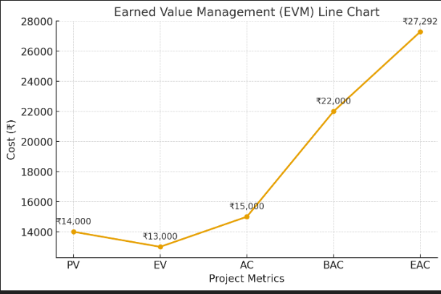

Q.4: Prepare a Gantt chart showing the percentage completion of tasks with current task status for Online medicine delivery management system. Assume suitable data and calculate CPI and SPI using EVA method.
Task | Budget (₹) | Planned % | PV (₹) | Actual % | EV (₹) | AC (₹)
Requirement | 2,000 | 100% | 2,000 | 100% | 2,000 | 2,000
Design | 4,000 | 100% | 4,000 | 90% | 3,600 | 4,300
Development | 10,000 | 50% | 5,000 | 45% | 4,500 | 8,800
Testing | 4,000 | 20% | 800 | 10% | 400 | 1,000
TOTAL | 20,000 |  | 11,800 |  | 10,500 | 16,100
EVA calculations (memorize these formulas)
- CPI = EV / AC = 10,500 / 16,100 = 0.65 → Cost performance poor (we're spending more than value earned).
- SPI = EV / PV = 10,500 / 11,800 = 0.89 → Schedule behind (less work done than planned).
(Optional)
- EAC (if both CPI & SPI influence) = BAC / (CPI × SPI) = 20,000 / (0.65 × 0.89) ≈ ₹34,463
- VAC = BAC − EAC = 20,000 − 34,463 = −₹14,463 (negative means over budget)
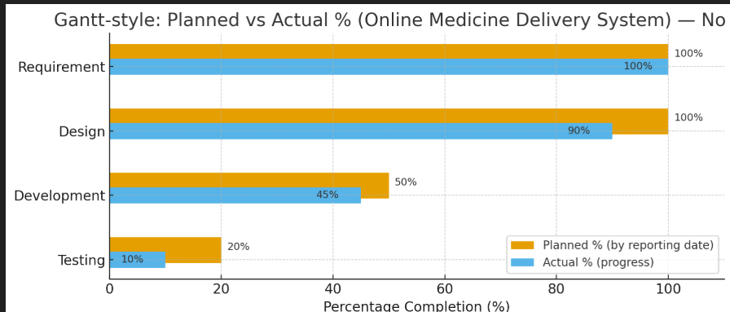

Q.9: For the earned value management, assume a hydroelectric power plant. This project is divided into 2 phases, each lasting 1 year.
- The first phase of the project is valued at ₹100,000.00
- The second phase is valued at ₹50,000.00
- At the current state, 1 year of the project has passed and 90% of phase 1 has been completed
- The project team has completed work worth ₹80,000.00
Task: Draw an EV analysis line chart for the same.
• Phase 1 value = ₹100,000 and Phase 2 value = ₹50,000 → BAC = ₹150,000.
• After 1 year (one full phase planned), PV = ₹100,000 (planned to finish phase 1).
• Phase 1 is 90% complete, so EV = 0.90 × 100,000 = ₹90,000.
• The line “project team has completed work worth ₹80,000” I used as the actual cost spent (AC = ₹80,000) — this interpretation fits EVA terms (AC is money spent).
Calculations (clean)
- PV = ₹100,000
- EV = ₹90,000
- AC = ₹80,000
- BAC = ₹150,000
- CPI = EV / AC = 90,000 / 80,000 = 1.125 → cost efficient (we spent less than the value earned).
- SPI = EV / PV = 90,000 / 100,000 = 0.90 → behind schedule (only 90% of planned work done).
(Optional)
- EAC (both CPI & SPI influence) = BAC / (CPI × SPI) = 150,000 / (1.125 × 0.90) ≈ ₹148,148.15
- VAC = BAC − EAC ≈ ₹1,851.85 (positive → still under overall budget projected)
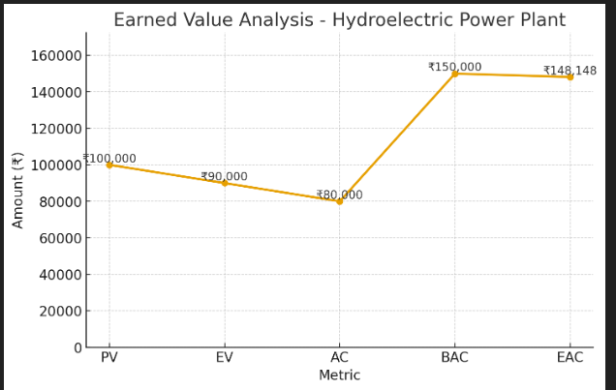

Q.6: Assume we are building a wind power plant.
- The project is set to be completed in 10 months with an estimated cost of ₹500,000.00
- The project has been running for 5 months
- The team has spent ₹220,000.00
- The team has completed an amount of work worth ₹255,000.00
Task: Draw a line chart for the same. Analyze the cost using EVA method.
Given
- BAC (estimated total cost) = ₹500,000
- Project duration = 10 months
- Months elapsed = 5 → Planned progress = 5/10 = 50%
- AC (actual money spent so far) = ₹220,000
- EV (value of work completed) = ₹255,000

Step-by-step calculations
- Planned Value (PV) = BAC × planned% = 500,000 × 50% = ₹250,000
- Earned Value (EV) = ₹255,000 (given)
- Actual Cost (AC) = ₹220,000 (given)
Performance indices:
- CPI = EV / AC = 255,000 / 220,000 = 1.1591 ≈ 1.16
→ CPI > 1 means cost performance is good: the team is getting more value per rupee spent.
- SPI = EV / PV = 255,000 / 250,000 = 1.02
→ SPI > 1 means schedule performance is slightly ahead of plan.
Optional forecasts:
- EAC (both CPI & SPI influence) = BAC / (CPI × SPI)
= 500,000 / (1.1591 × 1.02) ≈ ₹422,914.05
- VAC = BAC − EAC ≈ 500,000 − 422,914 = ₹77,086 (positive → forecasted to finish under budget)
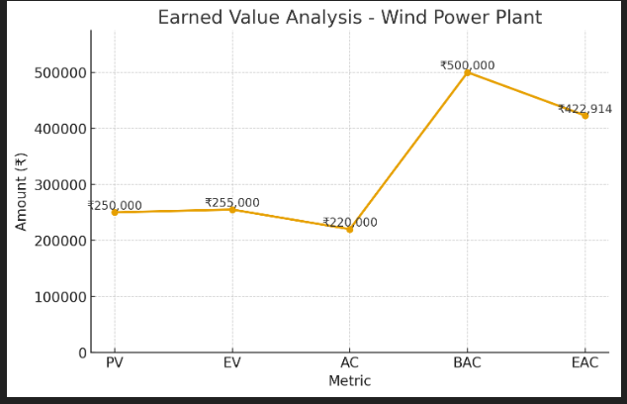

Q.8: A project is undertaken where the work has to be completed within 60 days with a budget of ₹20,000.
- The cost breakdown per month is ₹10,000
- The work scheduled in each month is half of the total work to be completed
- According to the progress reports, at the end of the first month, only 25% of the total work has been completed and 50% of the total budget has been spent
- For the completion of 25% work, the actual cost incurred is 50% of the total budgeted cost
Task: Make EV analysis, draw line chart for the same.

Given
- Project duration = 60 days (≈ 2 months).
- BAC = ₹20,000 (total budget).
- Cost breakdown per month = ₹10,000.
- Planned work: half the work each month → PV (end of month 1) = 50% of BAC = ₹10,000.
- Actual progress at end of month 1 = 25% of total work → EV = 25% of BAC = ₹5,000.
- Actual cost spent for that work = 50% of BAC = ₹10,000 → AC = ₹10,000.

Calculations
- PV = ₹10,000
- EV = ₹5,000
- AC = ₹10,000
- CPI = EV / AC = 5,000 / 10,000 = 0.50 → Cost performance is poor: getting only ₹0.50 of value per ₹1 spent.
- SPI = EV / PV = 5,000 / 10,000 = 0.50 → Schedule performance is poor: only 50% of planned work completed.
Optional forecast (if both CPI & SPI influence):
- EAC = BAC / (CPI × SPI) = 20,000 / (0.5 × 0.5) = 20,000 / 0.25 = ₹80,000
- VAC = BAC − EAC = 20,000 − 80,000 = −₹60,000 (negative → project forecasted to be over budget by ₹60,000)
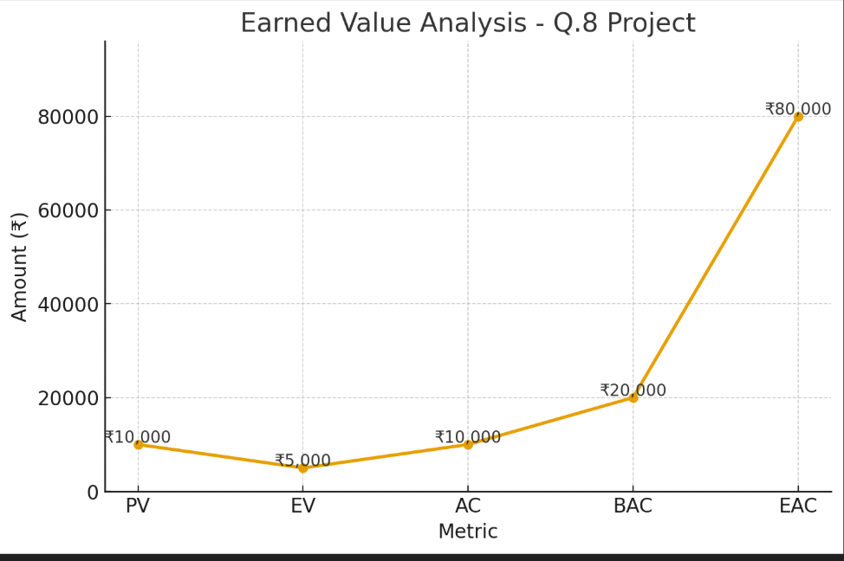

Q.12: Create a project dashboard for Online clothes delivery management system to show:
- Project summary
- Allocated resources
- Project completion cost and budget
- Allotted tasks
Make a CPM for the same.

Q.7: For the second Earned Value Management example, we are building a solar power plant.
- The project is divided into 5 stages, each worth ₹20,000.00
- Each stage is estimated to last for 1 month
- 2 months have passed
- 3 stages have been completed for a cost of ₹80,000.00
Task: Draw a line chart for the same
$$\text{BAC}=5×\text{₹}20,000=\text{₹}1,00,000$$Given:
- BAC = ₹1,00,000
- PV = ₹40,000 (after 2 months planned)
- EV = ₹60,000 (3 stages completed)
- AC = ₹80,000
Calculations:
- CPI = EV / AC = 0.75 → Cost efficiency is low (over budget)
- SPI = EV / PV = 1.5 → Ahead of schedule (faster progress)
- EAC = ₹88,889, VAC = ₹11,111
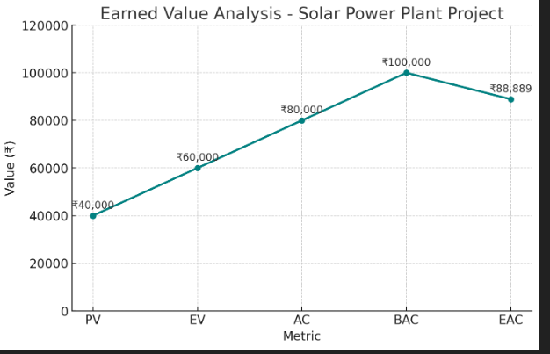

Q.3: Draw a line chart and bar chart for Online medicine delivery management system.
Compare the planned versus actual status of:
- Project cost
- Budget
- Resources allocated
Assume suitable data and make a CPM for the same.
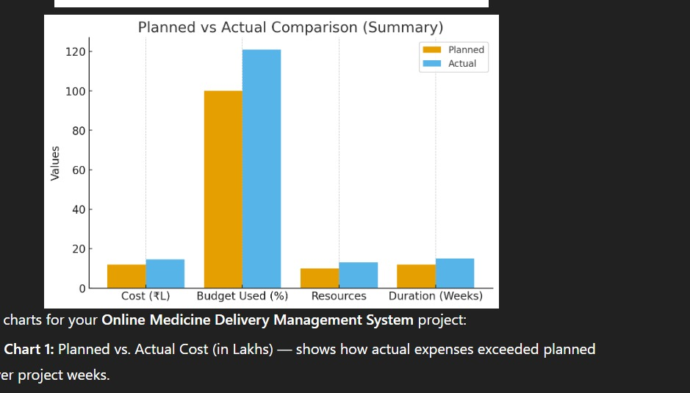
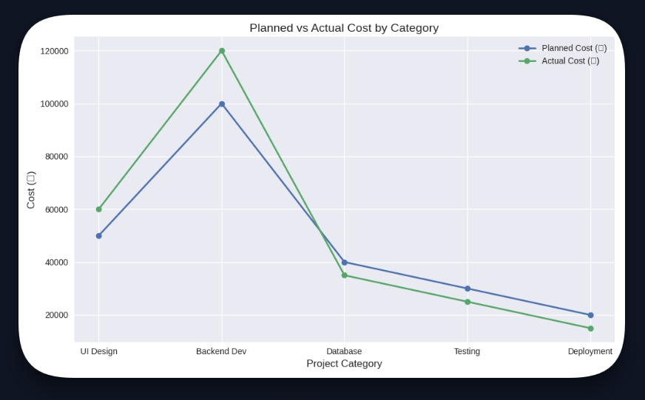
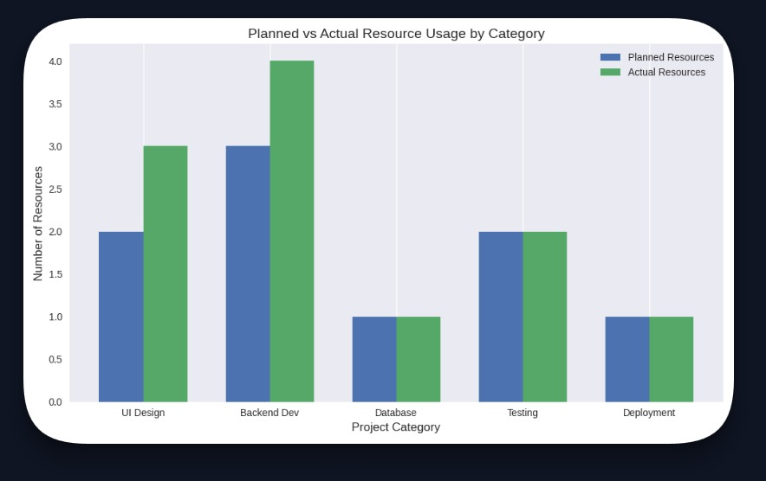
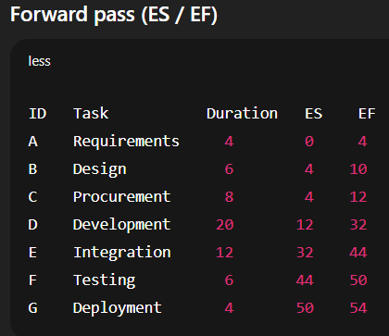
Q.1: Generate a pie chart and bar chart for Online movie ticket management system.
Compare the planned versus actual status of:
- Project cost
- Budget
- Resources allocated
Assume suitable data and make a CPM for the same.

2. Draw a pie chart and line chart for Online Food Delivery Management System.
Compare the planned versus actual status of the project cost, budget, and resources allocated.
Assume suitable data and make a CPM for the same.
Q.1. Create a project dashboard for Online Medicine Delivery Management System to show:
- Project summary
- Allocated resources
- Project completion cost and budget
- Allotted tasks
Make a CPM for the same.

Q.10. Create a project dashboard for Online Home Delivery Management System to show:
- Project summary
- Allocated resources
- Project completion cost and budget
- Allotted tasks
Make a CPM for the same.

